### Black Bobbin Wall Mirror Art

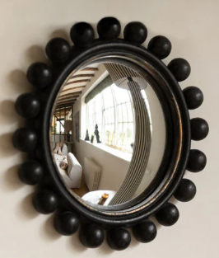The Black Bobbin Wall Mirror Art is a striking and sophisticated decorative piece that brings a touch of elegance to any room. Featuring a unique bobbin-inspired frame design, this mirror blends classic craftsmanship with modern aesthetics. The sleek black finish enhances its versatility, making it a perfect complement to various interior styles, from traditional to contemporary. The intricate bobbin detailing around the edges adds texture and visual interest, making this mirror not only a functional reflection but also a captivating work of art. Ideal for living rooms, hallways, or bedrooms, it elevates any space with its stylish and timeless appeal.